# Project: Product Shop

Product Shop is a system that registers users, categories, products and orders. It is a significantly big project, and as such it will have several parts. In this exercise you will land the basics of the application, in other words - the user functionality.

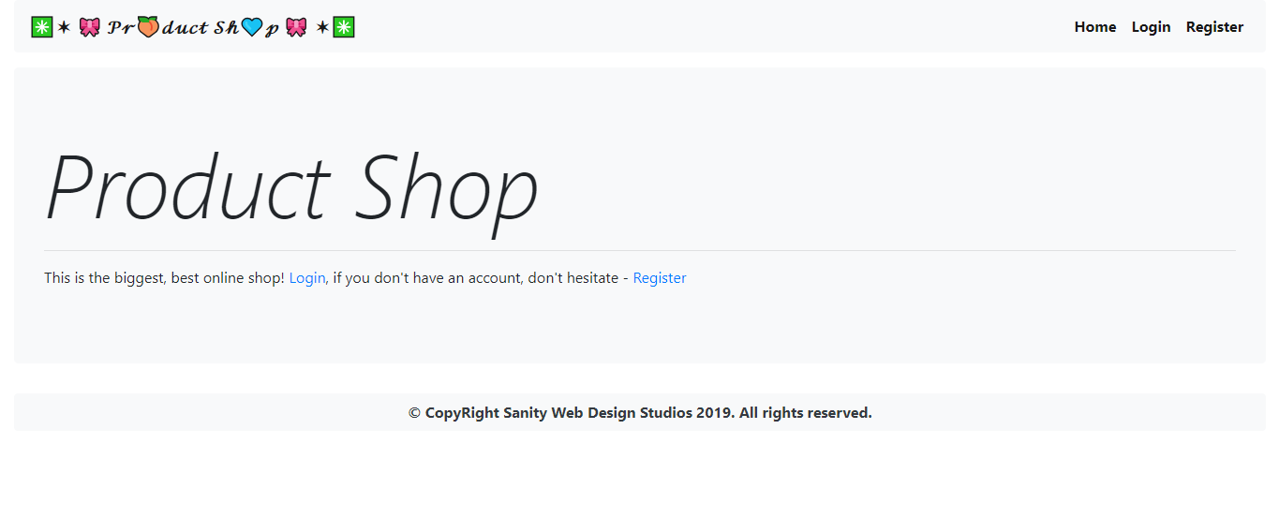

# Workshop: Part 4.5 – Error Handling

## Error Action & Error Page

By default, upon encountering an exception, Spring tries to find an action mapping at URL "/error". If it finds the mapping, Spring sends the error information there. If there is no such mapping, the Whitelabel page is visualized instead.

Your task is to implement an Error action mapping on "/error". It would be better if the action is in a separate controller. The action should return a simple Thymeleaf view, which you should also implement.

Visualize basic error data – **HTTP Status Code**, **Exception message** etc. Format it in a User-friendly way.

**NOTE**: The mapping type of the error action is a [GET] mapping.

## Basic Error Handling

Implement **global exception handlers**, for exceptions which may occur during **Framework processes**. For example, database exceptions, Spring request chain exceptions, etc.

The global exception handler should always return a **500 Internal Server Error**.

**NOTE**: If you implement everything correctly, it should result in the Error page, you’ve implemented in the previous task.

## Custom Error Handling

Implement **Custom Exceptions**, for every Application error you can think of, like requesting details about a non-existent Product, Ordering with invalid data etc.

Annotate the exceptions with the appropriate @ResponseStatus annotation.

Attach appropriate messages, which should be constants, for easy code maintenance.

**NOTE**: If you implement everything correctly, it should result in the Error page, you’ve implemented in the previous task.

## ** Setting up application environments

Do a little research on how you can setup environments in the Spring application. Setup a **Production environment** and **Development environment**.

In **Production environment** you should keep public error information to an **absolute minimum**. Only a User-friendly message and a status.

In **Development environment** you should present maximum information about the error. You should present error message, stack trace etc.